**Assignment -1**

Portfolio Website

|  |  |
| --- | --- |
| Assignment Date | 19 September 2022 |
| Student Name | Mr. Karthikeyan K R |
| Student Roll Number | 922519205052 |
| Maximum Marks | 2 Marks |

**Question-1:**

 Develop a sample homepage with html, CSS which should include banner, image & description about yourself and contact form.

Solution:

|  |
| --- |
| <html> |
|  | <head> |
|  | <title>Assignment</title> |
|  | <link rel="stylesheet" href="https://www.w3schools.com/w3css/4/w3.css"> |
|  | <link rel='stylesheet' href='https://fonts.googleapis.com/css?family=Roboto'> |
|  | <link rel="stylesheet"href="https://cdnjs.cloudflare.com/ajax/libs/font-awesome/4.7.0/css/font-awesome.min.css"> |
|  | <style> |
|  | html,body,div,h1,h2,h3,h4,h5,h6 {font-family: "sans-serif", sans-serif; font-weight: 700;} |
|  | img{ |
|  | display:block; |
|  | margin-left: auto; |
|  | margin-right: auto; |
|  | padding:20px; |
|  | } |
|  | .header { |
|  | padding: 60px; |
|  | background: #6ea3dc; |
|  | color: white; |
|  | font-size: 30px; |
|  | } |
|  | </style> |
|  | <body> |
|  | <div style="background-color: light-grey;"> |
|  | <div class="w3-container w3-right w3-xlarge"> |
|  | <i class="fa fa-facebook-official w3-hover-opacity"></i> |
|  | <i class="fa fa-instagram w3-hover-opacity"></i> |
|  | <i class="fa fa-snapchat w3-hover-opacity"></i> |
|  | <i class="fa fa-pinterest-p w3-hover-opacity"></i> |
|  | <i class="fa fa-twitter w3-hover-opacity"></i> |
|  | <i class="fa fa-linkedin w3-hover-opacity"></i> |
|  | </div> |
|  | <div><h3> Karthikeyan K R </h3> |
|  | </div></div> |
|  | <div class="w3-content w3-margin-top" style="max-width:1200px;"> |
|  |  |
|  | <!-- The Grid --> |
|  | <div class="w3-row-padding"> |
|  |  |
|  | <!-- Left Column --> |
|  | <div style="width: 100%;height: 50%"> |
|  |  |
|  | <div class="w3-white w3-text-grey w3-card-4"> |
|  | <div class="w3-display-container"> |
|  | <div class="header"> |
|  | <img src="KARTHIKEYAN.jpg" style="height:300px "> |
|  | </div> |
|  | <div class="w3-container"> |
|  | <p><h4><b>Name : </b> Karthikeyan K R </h4> </p> |
|  | <p><h4><b>Age : </b> 20 </h4></p> |
|  | <p><h4><b>Email : </b> karthi.btech2019@gmail.com</h4> </p> |
|  | <p><h4><b>Address : </b> Hanuman Kovil Street,Karur</h4> </p> |
|  |  |
|  | <hr> |
|  |  |
|  | <p class="w3-large"><b><i class="fa fa-asterisk fa-fw w3-margin-right w3-text-teal"></i> Technical Skills</b></p> |
|  | <p>Python</p> |
|  | <div class="w3-light-grey w3-round-xlarge w3-small"> |
|  | <div class="w3-container w3-center w3-round-xlarge w3-teal" style="width:90%">90%</div> |
|  | </div> |
|  | <p>Java</p> |
|  | <div class="w3-light-grey w3-round-xlarge w3-small"> |
|  | <div class="w3-container w3-center w3-round-xlarge w3-teal" style="width:80%"> |
|  | <div class="w3-center w3-text-white">80%</div> |
|  | </div> |
|  | </div> |
|  | <p>C++</p> |
|  | <div class="w3-light-grey w3-round-xlarge w3-small"> |
|  | <div class="w3-container w3-center w3-round-xlarge w3-teal" style="width:75%">75%</div> |
|  | </div> |
|  | <p>Ruby</p> |
|  | <div class="w3-light-grey w3-round-xlarge w3-small"> |
|  | <div class="w3-container w3-center w3-round-xlarge w3-teal" style="width:50%">50%</div> |
|  | </div> |
|  | <br> |
|  |  |
|  | <p class="w3-large w3-text-theme"><b><i class="fa fa-globe fa-fw w3-margin-right w3-text-teal"></i>Scripting Languages</b></p> |
|  | <p>HTML</p> |
|  | <div class="w3-light-grey w3-round-xlarge"> |
|  | <div class="w3-round-xlarge w3-teal" style="height:24px;width:100%"></div> |
|  | </div> |
|  | <p>CSS</p> |
|  | <div class="w3-light-grey w3-round-xlarge"> |
|  | <div class="w3-round-xlarge w3-teal" style="height:24px;width:55%"></div> |
|  | </div> |
|  | <p>JAVASCRIPT</p> |
|  | <div class="w3-light-grey w3-round-xlarge"> |
|  | <div class="w3-round-xlarge w3-teal" style="height:24px;width:25%"></div> |
|  | </div> |
|  | <br> |
|  | </div> |
|  | </div><br> |
|  | </div> |
|  |  |
|  | </body> |
|  | </head> |
|  | </html> |

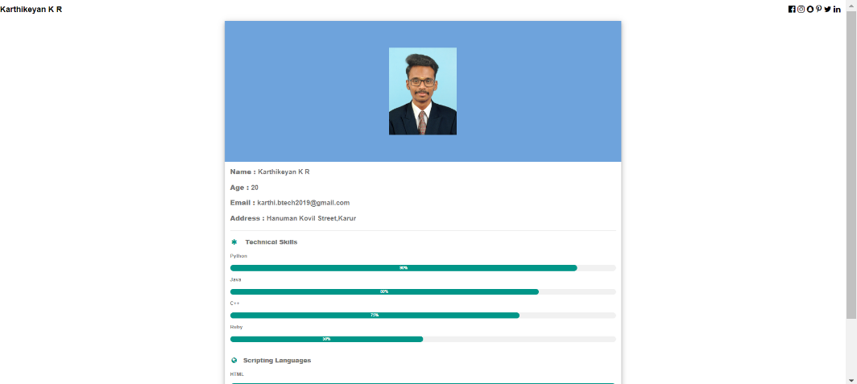Output: